**Activity #3**

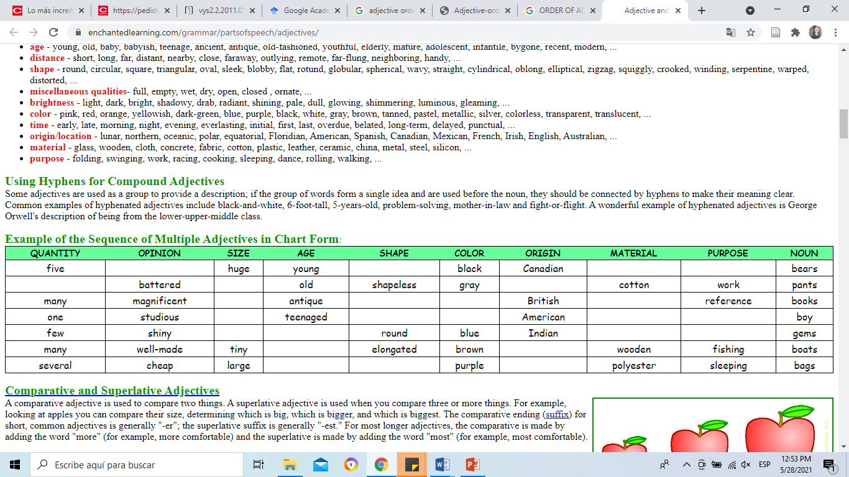

**PART 1**

**Instructions: Put the following adjectives in the correct order.**

1. Our school is in a big old rectangular (big, old, rectangular) building.
2. We have two interesting English (English, interesting, two) classes this week.
3. We have a few tasteless tiny (a few, tasteless, tiny) hot dogs for dinner.
4. We drink some sweet orange American (American, orange, sweet) lemonade.
5. We meet a group of five smart young (five, smart, young) authors.
6. Today, we have a difficult extensive math (difficult, extensive, math) exam.
7. We are selling our ugly tiny broken (broken, tiny, ugly) car.
8. They sell colorful round Southern (colorful, round, Southern) cacti.
9. We are looking for some fresh red (fresh, red, some) apples.
10. This restaurant had some delicious Atlantic (Atlantic, delicious, some) crabs.
11. Aunt Lucy bought an antique wooden rocking (antique, rocking, wooden) chair.
12. Jason wrote a long new horror (horror, long, new) novel.
13. Ansgar joined an ambitious rich soccer (ambitious, rich, soccer) team.
14. Alex watched the pale blue northern (blue, northern, pale) sky.
15. Tony survived a violent big electric (big, electric, violent) storm.
16. Mary fell in love with a good-looking tall strapping (good-looking, tall, strapping) man.

**PART 2**

**Instructions:** Write sentences that include the indicated type of adjectives for each one. Underline, mark with a different color, or **put in bold** the adjectives so I can identify them.

Try to not repeat adjective in the sentences and use different ones.

For example:

**Opinion, color, material**

She bought a **beautiful, pink, silk** dress for the ceremony.

1. Size, shape, material

Roberta is now looking for his **elegant round wooden** table.

1. Opinion, origin

Michael has forgotten the **delicious Mexican** tortillas for his breakfast.

1. Size, age, shape

Susan will buy a **long new wig** for his grandmother.

1. Color, origin, material

I am going to give my mother a **red American titanium** truck.

1. Opinion, age, shape

She is not okay the **ugly new thick** book was torn apart by raccoons.

1. Opinion, color, material, purpose

Chloe is very mad with Dan he forgot that she wanted a **perfect blue cotton eating** candy.

1. Size, shape, material

Karen has called the manager because the **big round natural** hamburger is not that big.

1. Age, shape, color

Juan has bought a **medieval pointy black** sword for his contest. He’s definitely going to win.

1. Origin, material, purpose

My mom is very happy with the **Russian porcelain cooking** pan.

1. Opinion, size, age, shape, color, origin, material, purpose

Teacher Noemi gave an example to the students on how to use the osascomp acronym. She said “The **cute little young chubby white African meat riding** pony.”